**Appendix A**

**Appendix -Research Paper**

**Gymnasium Simulator**

Mohsin Iqbal Vohra1, Muhammad Anas2,Syed Muhammad Daniyal Nazar3,

Syed Muhammad Zuhair4, Sameer Khan5

Computer Engineering Department, Sir Syed University of Engineering and Technology, Karachi

[mvohraz@gmail.com1](mailto:mvohraz@gmail.com1), [CE18-145@ssuet.edu.pk2](mailto:CE18-145@ssuet.edu.pk2), [CE18-166@ssuet.edu.pk3](mailto:CE18-166@ssuet.edu.pk3), [CE18-156@ssuet.edu.pk4](mailto:CE18-156@ssuet.edu.pk4),

[CE-159@ssuet.edu.pk5](mailto:CE-159@ssuet.edu.pk5)

**Abstract -**Gymnasium Simulator is a mobile application that provides simulation of exercises for both male females. The main key aspect of the application is fitness. Gymnasium Simulator is based on the idea of self-training and it provides you with every ounce of knowledge needed to improve your body. It provides you work-out routines based on own body, if you don’t know your body type, an algorithm is implemented that will determine your body structure. There are several other features such as Daily Calories required, Nutrition Calculator, Calories Burned Calculator and a Competition System.

**Keywords: Fitness, Calorie**

**1-INTRODUCTION**Gymnasium Simulator is an application centered around being fit, healthy and physically attractive. The application is a free for all. Anyone can get benefit from this application. Application works in a way that first a user must register themselves in the application, so that only valid users with authentic information can register and use the application. This is a necessary step. Once that’s done, users are directed toward the home screen and from there he can access different widgets such as Drawer, Calorie Calculator, Exercises, Calories Burned, Nutrition Calculator. The Drawer contains user information panel, several other widgets and a Logout button. The Calorie Calculator, Calories Burned and Nutrition Calculator are basically calculators that implements several mathematical formulas which will enable user to calculate his calories and nutrition based on his physical credentials. The Exercise widget contains exercises based on body types, if the user doesn't know his body type, he can choose select the option "Find your Body Type" which implements an algo which will determine his body type, user just have to let the camera scan his/her body. That way users do not have to do all any unnecessary exercises and they can follow workout routines which are ideal for their body type and body specific goals.

FITNESS APPs

The influence of APP technology, globally is increasing day by day and it is indirectly affecting the health care system. The fitness app industry has grown 504.45% - from 2017 to 2021, going from 2.68 million downloads to 16.2 million downloads. These App helps users to keep track of their Calories-in and Calories-out, they are also helpful in measuring the progress of the user.

**2-RESEARCH**We reviewed several scholarly sources (articles, researches, studies) and even carried out a survey before developing our project to get an understanding of what are the features, we can implement within our project that would benefit our users and would also be unique.

**SURVEY**

We conducted an online survey to determine what are the main motives that forces people to go to the Gym.

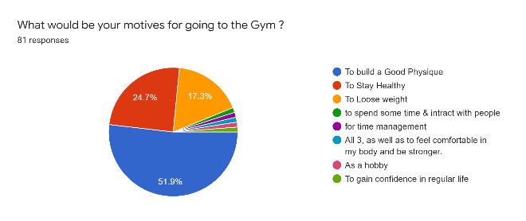

Fig 1: Survey Pie chart

50% of respondents to the survey, wants to build a Good physique, 24.7% wants to stay healthy and 17.2% wants to lose weight. Based on this statistic we developed an Application that would guide users in the gym and maximize results based on their preferred goals.

LITERATURE REVIEW

In this paper [1] Researchers conducted an empirical study in which participants were asked to evaluate their receptiveness toward application features such as Goal-Setting, Self-Monitoring, Reward, Learning etc. The study concluded that Goal-Setting, Self-Monitoring is the strongest predictor of the intention to use a fitness app, followed by Reward and Competition.

Based on these findings we implemented the Scoring system, that takes in the Number of Weeks User has worked out and assign points based on that. This feature enables them to compare their progress with other user and reflect on their progress.

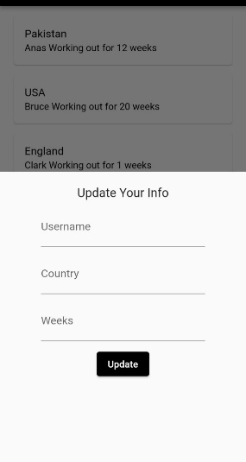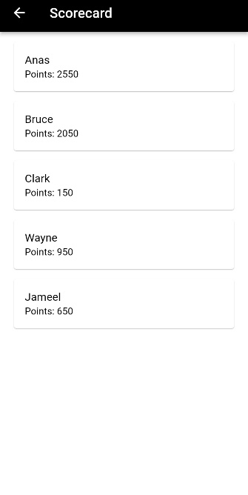

Fig 2: Update Profile and Score

In this paper [2] Interventional study, with a total number of 45 healthy male volunteers between the age of 22-28 were observed and different exercises were prescribed to them based on their body type. The statistical analyses were carried out with the SPSS software version 16. This study reports that exercising based on body types will provide the best results in health-related fitness components designed by the ACSM (American College of Sports Medicine).

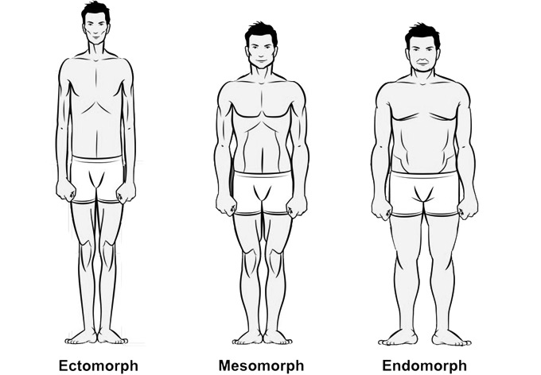

. Fig 3: Body Types

Based on these findings we designed workout routines for all three body types, with the help of a professional trainer.

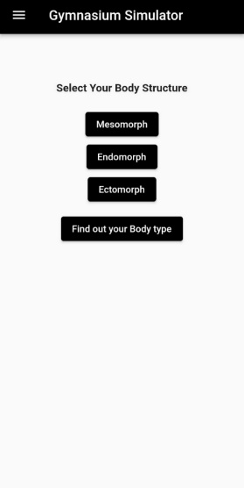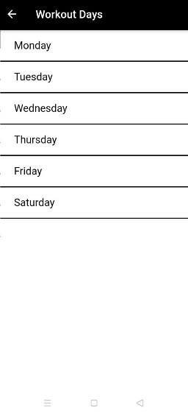

Fig 4: Workout Routine

[3] Harris–Benedict equations, to calculate the Base Metabolic Rate (BMR),

For men:

BMR = 13.397W + 4.799H - 5.677A + 88.362

For women:

BMR = 9.247W + 3.098H - 4.330A + 447.593

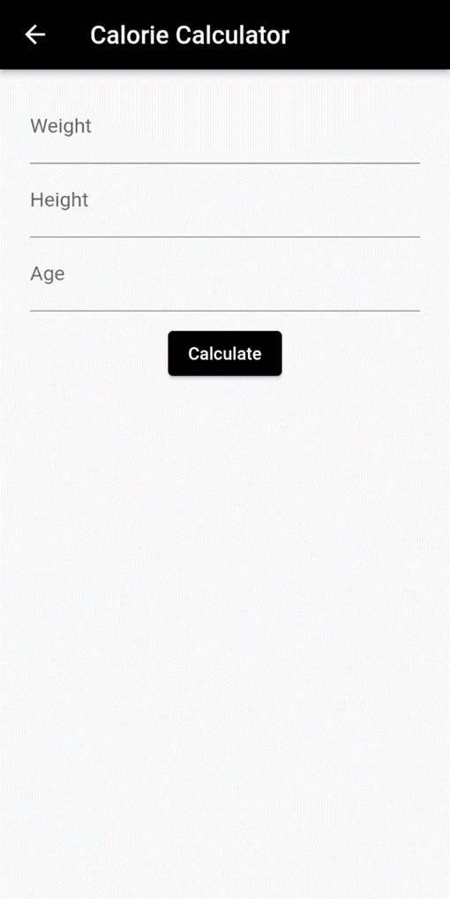

Fig 5: Calorie Calculator

Revised Harris-Benedict works with three parameters:

• Weight

• Height

• Age

[4] Teachable Machine, web-based GUI tool for developing custom machine learning classification models without specialized technical expertise. Teachable Machine lets you train machine model to recognize images, sounds, & poses.

By using Teachable Machine, we trained a model to recognize Endomorph Male, Endomorph (Female), Mesomorph (Male), Mesomorph (Female), Ectomorph (Male), Ectomorph (Female) and people with higher bodyfat. After training the model we converted it into a TF-lite file and implemented it within our Application. This will recognize the body type of the user.

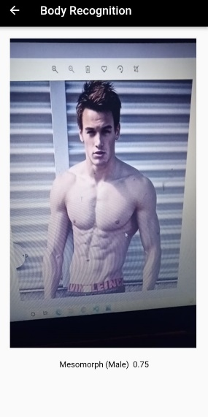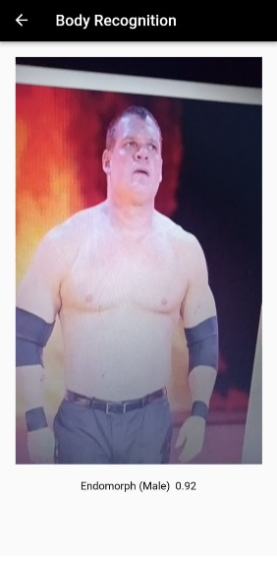

Fig 6: Body Recognition

**3-OBJECTIVES   
i.** Guide regular people into the world of fitness. **ii.** To build awareness regarding the subject of fitness.

**4-DFD**Data Flow Diagram of the Application is as follow:

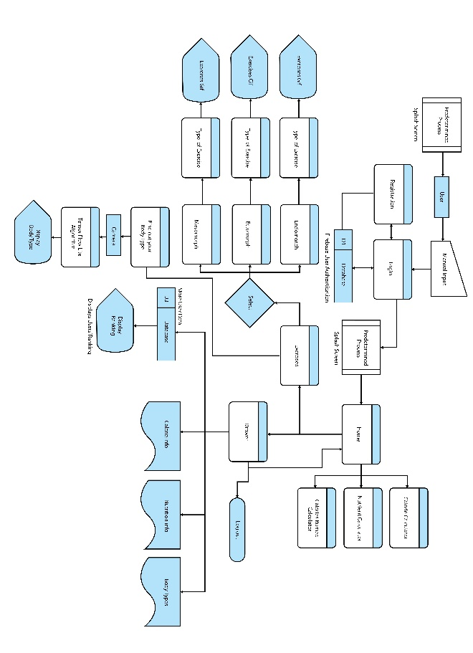

Fig 7: Data Flow Diagram

**5-Use Case Diagram**Data Flow Diagram of the Application is as follow:

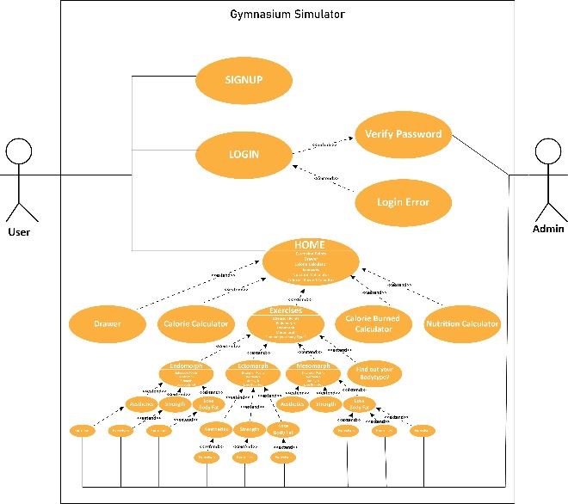

Fig 8: Use Case Diagram

**6-Activity Diagram**Activity Diagram of the Application is as follow:

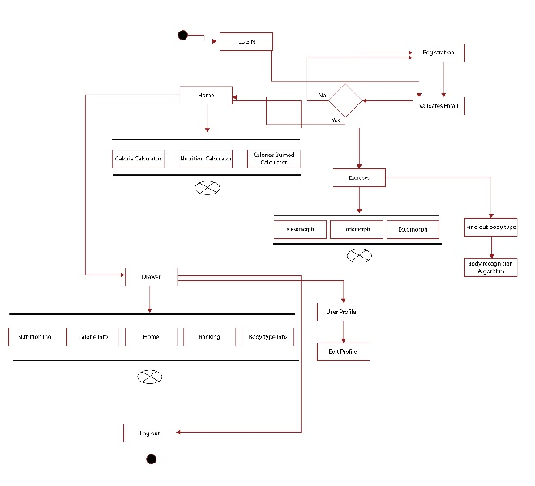

Fig 9: Activity Diagram

**7-Entity Relationship Diagram**ER Diagram of the Application is as follow:

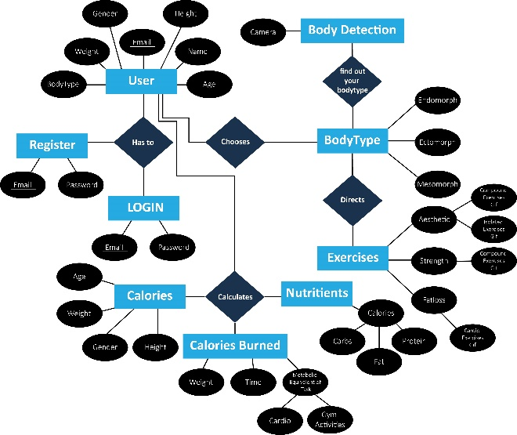

Fig 10: Entity Relationship Diagram

**8-TESTING**To verify whether the actual software program matches expected requirements and to confirm that software product is defect free. We have tested our software project with Black Box Testing. We test the Functional Features with

• Unit Testing

• Integration Testing

The results are positive, each and every function of the project works.

**9-CONCLUSION**In conclusion, we’ve developed an application that serve the purpose of being an ultimate guide for beginner weight lifters. There are several functionalities that will help and guide users toward achieving their ideal physique and being healthy.

**ACKNOWLEDGEMENT**

All praises are for Allah, for giving us this opportunity, the strength and the patience to complete our FYP, after the challenges and difficulties.

Secondly, we would like to thank our internal advisor Sir Mohsin Iqbal Vohra for his guidance, motivation and his most significant contributions in this project. We were very blessed that our supervisor turned out to be such a humble, gentle, thoughtful, supportive, cooperative and obliging person. Words aren’t enough to express our gratitude towards him.

Finally, we would also like to thanks our parents for financial and moral support and our friends who have helped and motivated us throughout the project.

**REFERENCES**

1- Oyibo K, Vassileva J. “Persuasive Features that Drive the Adoption of a Fitness Application and the Moderating Effect of Age and Gender” Multimodal Technologies and Interaction. 2020;

2- Kathirgamam V, Ambike M, Bokan R, Bharambe V, Prasad A. “Analyzing the effects of exercise prescribed based on health-related fitness assessment among different somatotypes” Journal of Health Sciences. April 2020;

3- Harris JA, Benedict FG. "A Biometric Study of Human Basal Metabolism" Proceedings of the National Academy of Sciences of the United States of America. (1918);

4- Chen A, Pitaru A, Webster B, Alvarado I, Griffith J, Phillips K, Carney M, Howell N, Jongejan J. Teachable Machine: Approachable Web-Based Tool for Exploring Machine Learning Classification. (2020);